PROJECT TITLE

Sale Analysis for the Year 2023

CLIENT NAME

RETAIL BUSINESS

*ANONYMOUSE.*

Implemented

By

Taiwo Oluwafemi

*Data Analyst*

13/11/2021

Introduction

Actually, the business year seems to underperform compare to previous year in the organizations, considering the profit and business activities recorded in the books. Hence, management and major stakeholders has demanded for a holistic review of the past year (i.e. 2023) performance, by analysis business data. This approach will enable the business to answer some fundamental questions, relating to some impeding factors to better performance for the year under review, and also enable the business to identify trend and opportunity for growth in the coming year. The fundamental questions to be answered with the data, as provided by the major stakeholders are;

* What is total sales for the year (i.e. 2023)?
* What are the monthly sales for the year?
* The products categories sold in the year and their corresponding market share.
* What is the total sales by gender?
* What is the monthly sales by product?
* What is the yearly sales by product and by gender?
* What is the age distribution of the customers that made purchase in the year under review?

About the Data

The dataset used for the analysis was collected for all sales transactions in the ERP system from 1st of January 2023 till 31st December 2023, which amount to a total of 999 rows (records) of data. The variables included in the dataset are;

* Transaction ID
* Transaction date
* Customer ID
* Gender of customer
* Customer’s age
* Product category
* Product quantity sold
* Unit price of product sold

Then, from the original dataset collected, the following variables were derived to enable visualization and provision of insight according to the stakeholder’s requirements.

* Month name of the year. Derived from transaction date
* Age category of the customers, base on the categories in figure 1 as provided by the stakeholders.
* Total sales amount. Derived with the product of the quantity sold and unit price.

|  |  |  |
| --- | --- | --- |
| **S/N** | **Age** | **Age group** |
| 1 | 0 | Under 18 |
| 2 | 18 | 18-21 |
| 3 | 21 | 21-30 |
| 4 | 30 | 30-50 |
| 5 | 50 | 50-60 |
| 6 | 60 | 60-70 |
| 7 | 70 | 71-80 |
| 8 | 80 | 80+ |

*Figure 1. Age categories*

Observations.

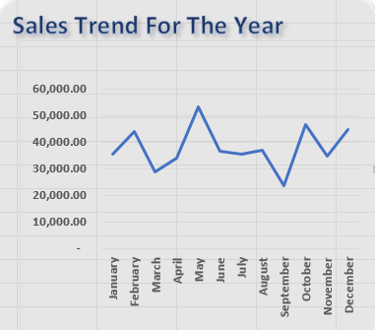

*Figure 2. Monthly sales for the year.*

* The total sales for the year is **454,470.00**
* The month of May has the highest sales spike in the year, with a value of **53,150.00**.
* The lowest dip in sales happened in September with a values of **23,620.00**.
* A steady increase in sales was observed for three months consecutively between the months of **March** to **May.** These period coincides with the period of sales promotion.
* Also, a sudden drop in sales between May and June. And, sales was almost steady for 3 month between **June** and **August** before the lowest sales dip happened in September. These periods coincides with the end of sales promotion.

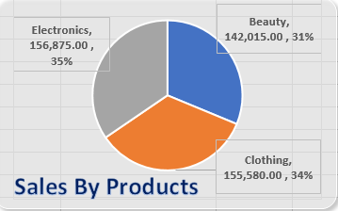

*Figure 3. Sales Product Market Share*

* The three product categories purchased in the year under review are **Electronics**, **Beauty** and **Clothing** products.
* **Electronics** products did **35%** of the year total sales, while **Beauty** products and **Clothing** products did **31%** and **34%** respectively. These difference are not significant, hence, these product categories has almost equal preference overall for the year.

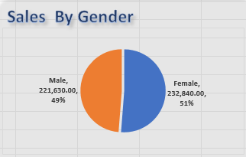

*Figure 4. Sales Customer Gender*

* **Male** customers did **49%** of the year total sales, while **Female** customers did **51%**. The difference is not significant
* Hence, customer gender segregation may not have significant effect on the overall sales performance.

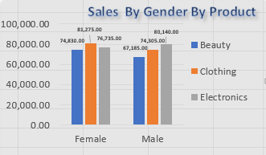

*Figure 5. Sales Customer Gender*

* Overall, **female** customers are buying more of **Beauty** products with value of **74,830.00** and **Clothing** product with value of **81,275.00** than **male** customers with values **67,185.00** and **74,305.00** respectively.
* However, **male** customers are buying more **electronics** with the value of **80,140.00** than the female that did only **76,735.00** in the year.

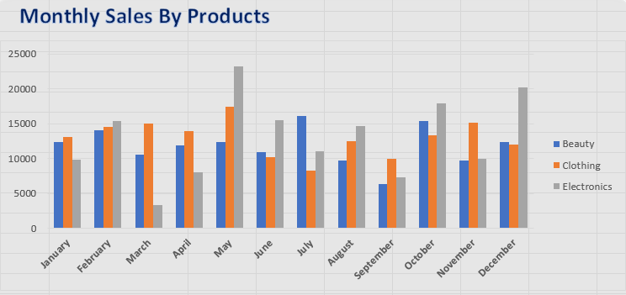

*Figure 6. Monthly Sales by Products.*

* There is a spike of electronics product sales in **May** and **December**. These periods coincides with the sale promotion and festive periods respectively. This means that, customers buys more electronics during festive period in December even without sales promotion.
* Also, the steady increase in the monthly sales from **March** to **May** was majorly influenced by the steady increase in the purchase of electronics between these periods.
* This means that, the sales of electronics benefited more from the sales promotion that ran between these periods than other products.

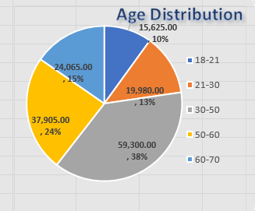

*Figure 7. Monthly Sales by Products.*

* Customers between age group of **30-50years** has a percentage share of **38%** and the highest purchases, follow by customers between **50-60years** with percentage share of **24%**.
* Customers that had least purchases are in age group between **18-21years,** follows by **21-30years**, then **60-70years** with percentage share of **10%**,**13%** and **15%** respectively.

**Conflict and Resolution**

There are no significant challenges or limitation in the dataset. However, there were two transactions already posted in the current year (2024) when the data were collected from the data source, but were excluded from the dataset. Hence, the exclusion of these two records did not impact the entire work and the conclusion in any way.

**Conclusion**

Leveraging on data in decision-making can enable businesses or organizations to making effective strategic plans towards the future of the business. Hence, the insight provided in this project regarding the segregation of customers by age, considering the value each category has contributed to business in the past year. Also, the positive impact of the sales promotion on the sales of electronic products, and the high demand of electronic products at the end of the year, can be adapted into actionable steps towards better strategic planning and improved sales performance in the coming year. For effective implementation of these finding, I am available for further discussion and collaboration.